LAB SESSION 2
Programming Exercise:
Question 1: Any character is entered by the user; write a program to determine whether the character entered is a capital letter, a small case letter, a digit or a special symbol.

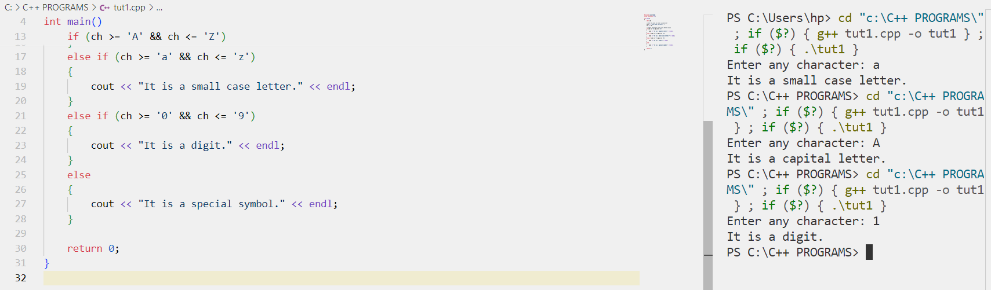

Question 2: Write a C++ program to generate the multiplication table of a given number.

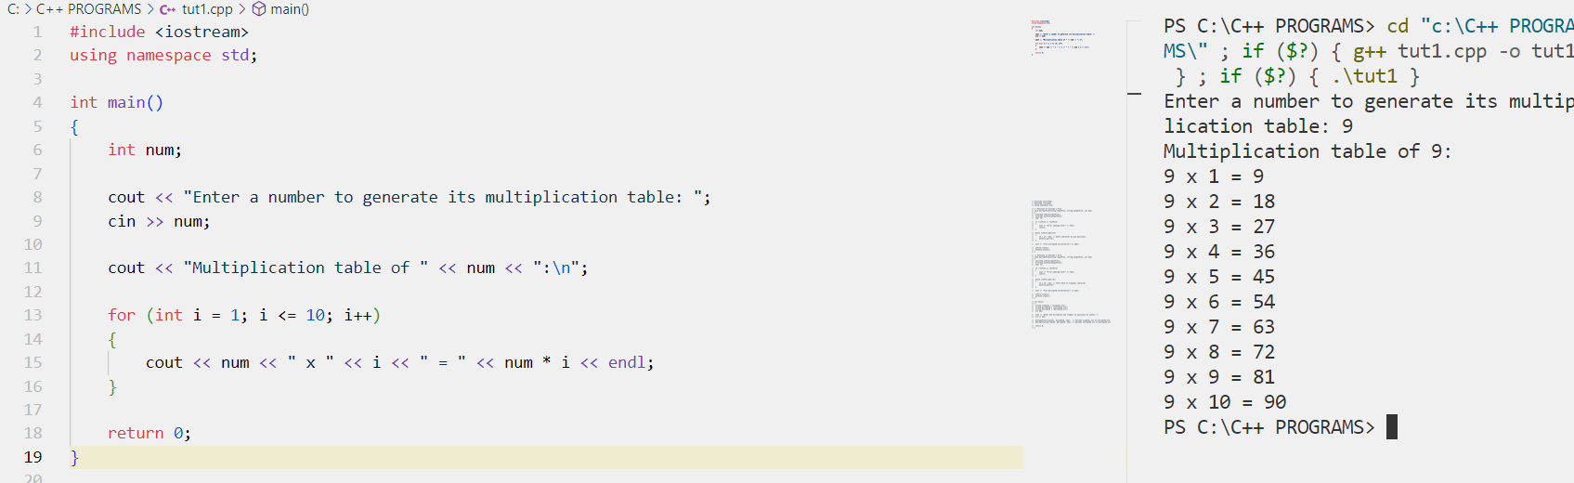

Question 3: Write a program to calculate the monthly telephone bills as per the following rule:
Minimum Rs. 200 for upto 100 calls.
Plus Rs. 0.60 per call for next 50 calls.
Plus Rs. 0.50 per call for next 50 calls.
Plus Rs. 0.40 per call for any call beyond 200 calls.

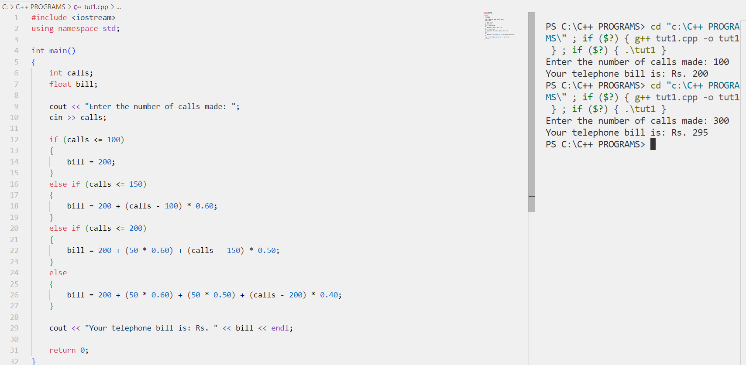

Question 4: Write a program to check the strength of a password entered by the user. The strength of the password is determined based on the following criteria:
• Minimum length of 8 characters.
• Contains at least one uppercase letter, one lowercase letter, one digit, and one special character.
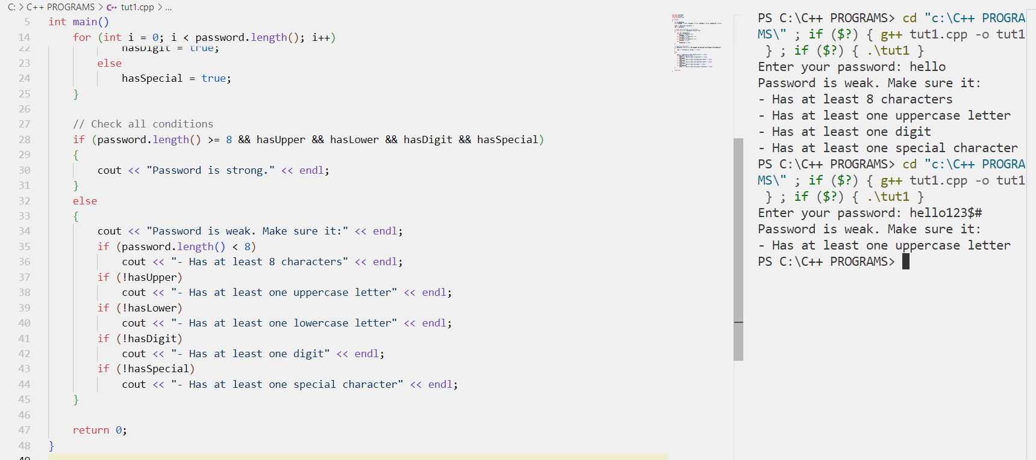

Question 5: Write a program to encrypt and decrypt a text file using a simple encryption algorithm. The encryption algorithm involves shifting each character by a fixed number of positions in the ASCII character set.
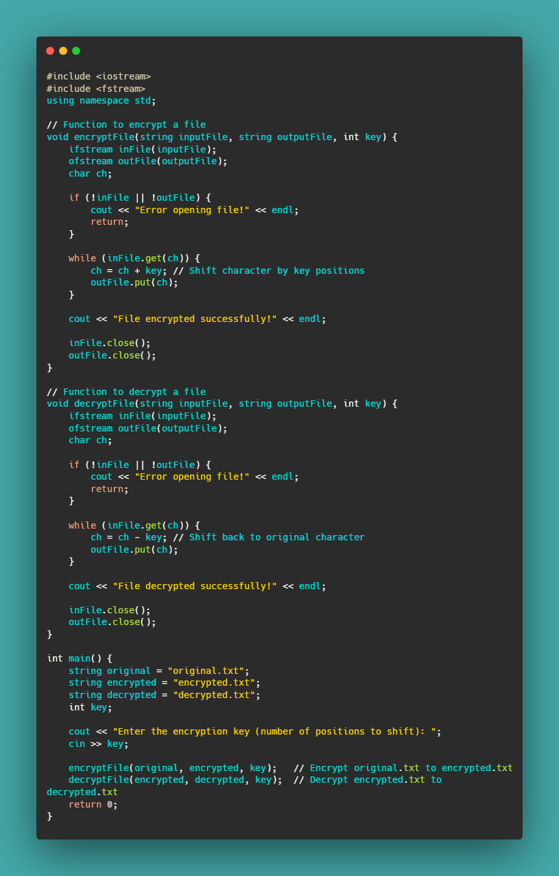
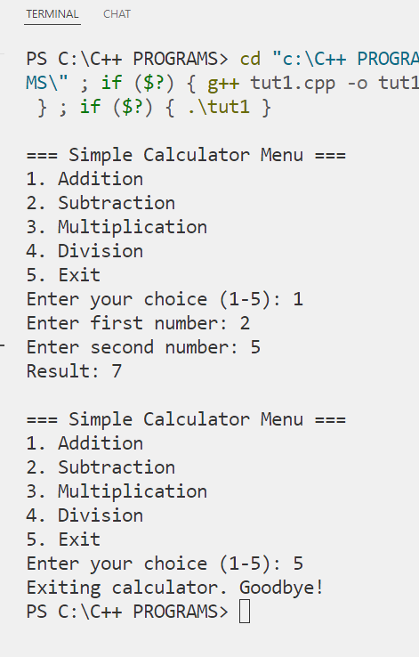
Question 6: Write a C++ program to create a simple menu-driven calculator that performs basic arithmetic operations (addition, subtraction, multiplication, division).

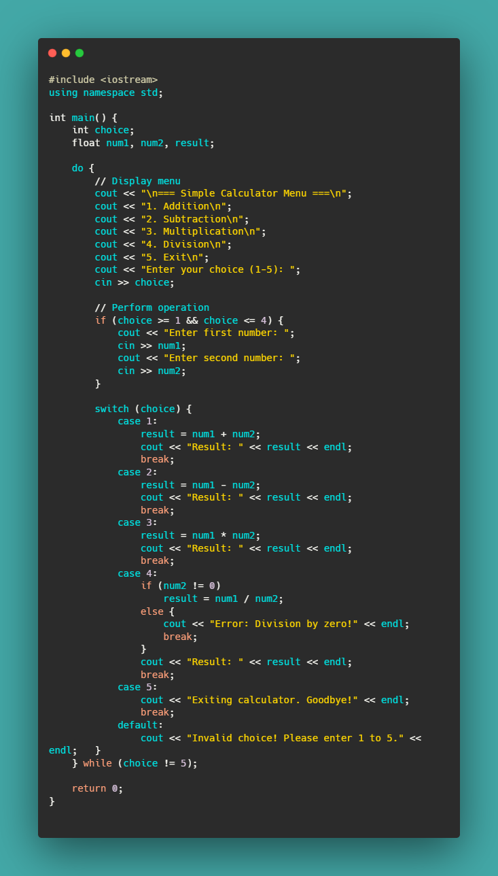
Question 7: Write a C++ program to generate the Fibonacci series up to a given number of terms.

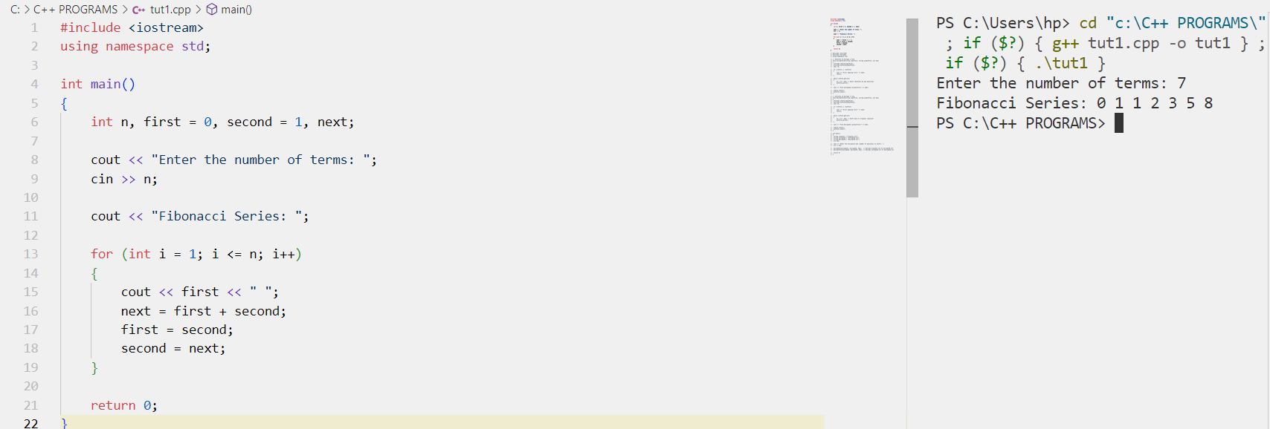

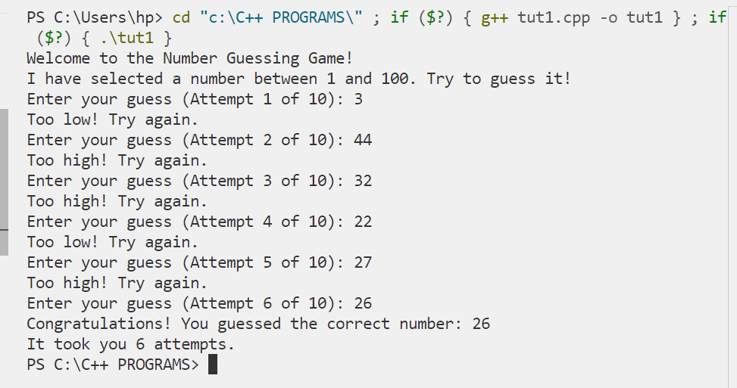
Question 8: Write a C++ program to implement a number guessing game where the user tries to guess a randomly generated number.
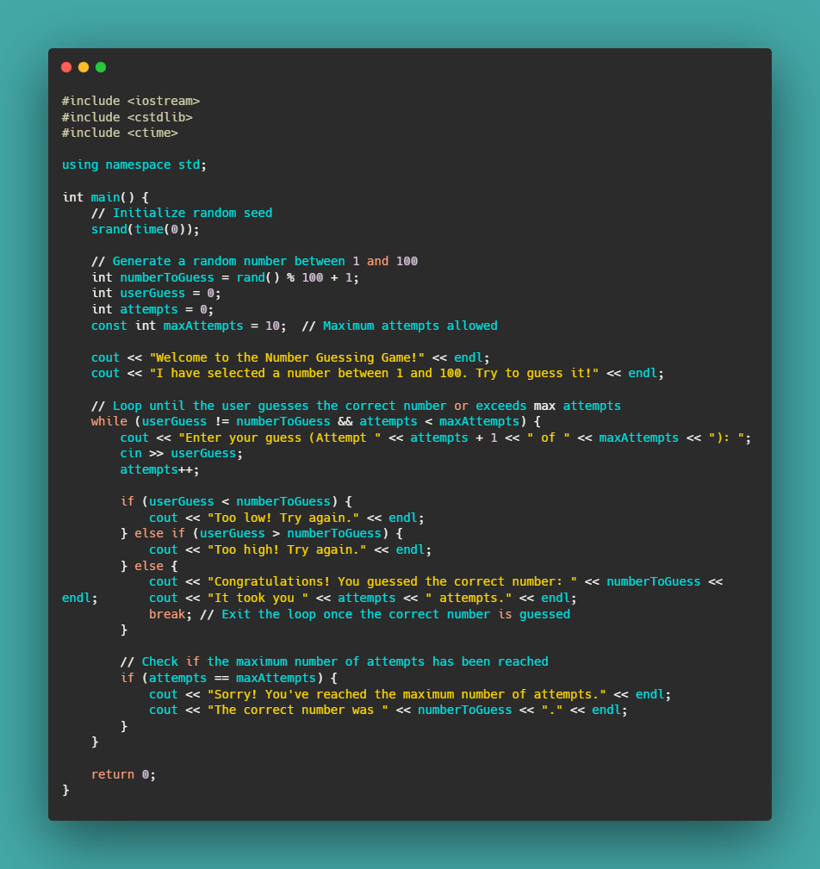

Q9) Write a C++ program to implement a simple rock, paper, scissors game between the user and the computer.
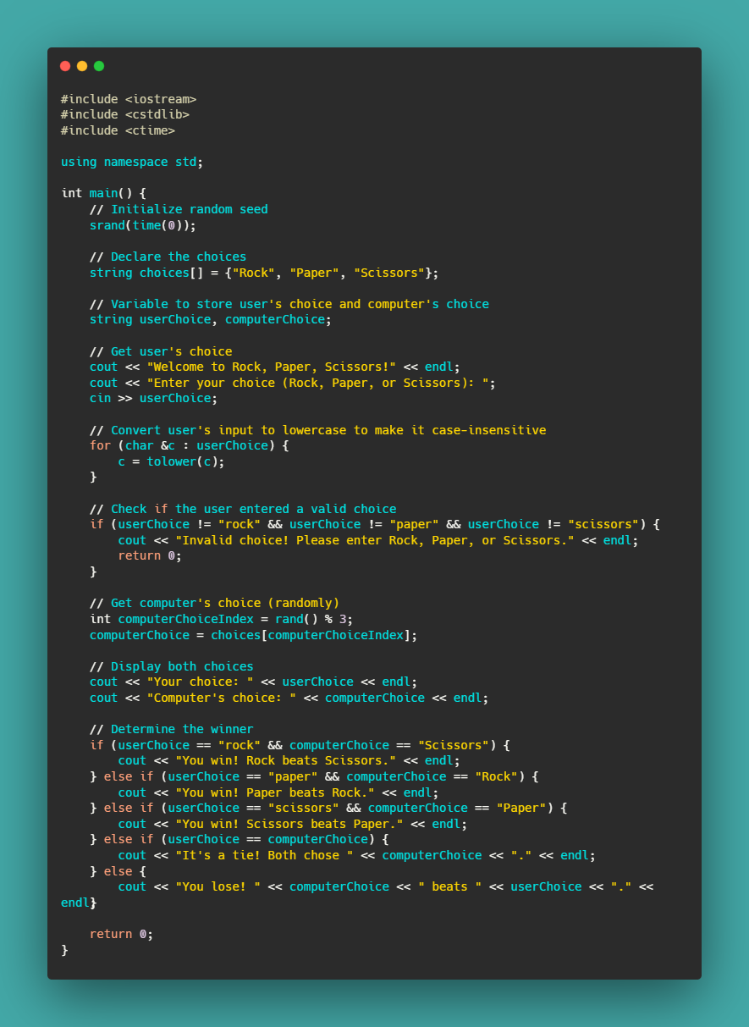
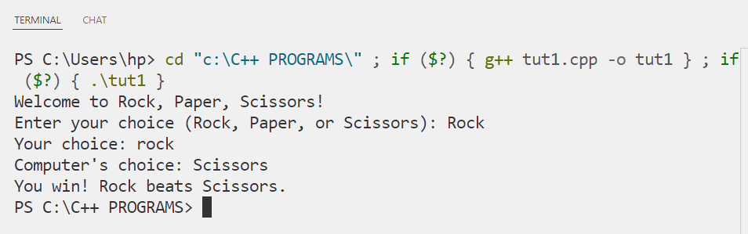

Question 10: Write a C++ program to display the name of the day of the week based on the day number entered by the user.
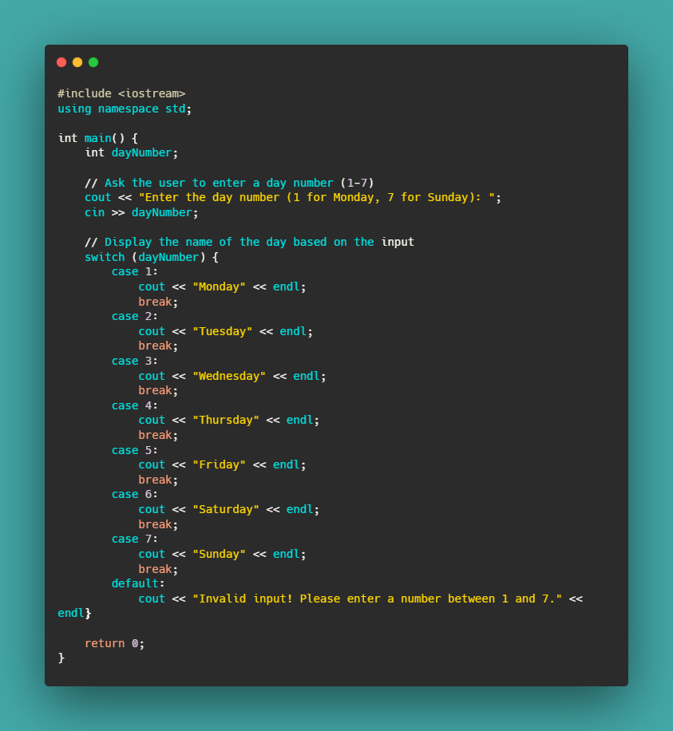
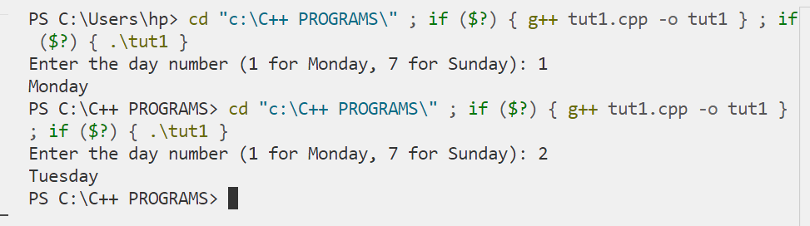

Question 11: Write a C++ program to print the following patterns and shapes:
